**Steps**

1. First upload “BareMinimum” from example to Arduino UNO.
2. Wire up the ESP8266 WiFi Module to Arduino

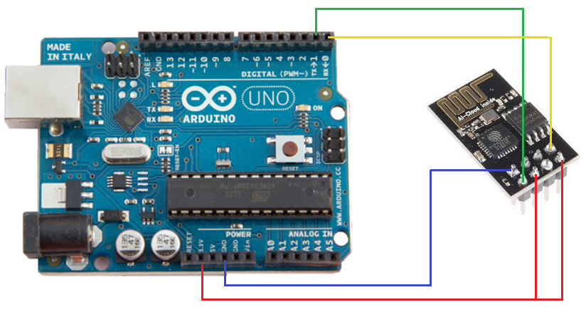

**Initial Programming of ESP8266**

1. Connect the Arduino Uno to your computer, and open the serial monitor from Arduino IDE (Tools -> Serial Monitor or Ctrl+ Shift + m). At the bottom of the serial monitor there are dropdowns set line endings to “Both NL & CR” and change the baud rate to “115200”. Then send the following commands as:
2. **To verify that the ESP8266 is connected properly.**

Send the Command: AT  
 Reply: OK

1. **Change the ESP8266 Working Mode.**

Send the Command: AT+CWMODE=3  
Reply: OK

1. **To connect to your WiFi (Type your WiFi name and Password)**.

Send the Command: AT+CWJAP= "**WiFi name** ", " **Password**”  
Reply :

WIFI CONNECTED  
WIFI GOT IP  
OK

1. **Now Set baud rate to 9600 as Arduino communicate at this rate**

Send the Command AT+UART=9600,8,1,0,0  
Reply: OK

1. **No Again verify that the ESP8266 is communicating at baud rate 9600.**

Send the Command AT  
Reply: OK

1. **Now verify the connection and IP address by.**

Send the Command: AT+CIFSR

Reply:

+CIFSR:APIP,"192.168.4.1"

+CIFSR:APMAC,"be:dd:c2:7a:f9:3a"

+CIFSR:STAIP,"192.168.0.19" (My IP Address, for your sit may be different)

+CIFSR:STAMAC,"bc:dd:c2:7a:f9:3a"

* If you know more command, hook-up on <http://room-15.github.io/blog/2015/03/26/esp8266-at-command-reference/>